RETIRED AIR FORCE OFFICER & EXECUTIVE LEADERSHIP COACH

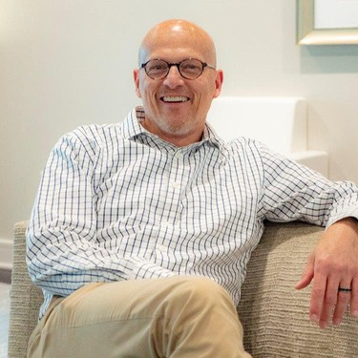
Mark Noon excelled in military and civilian healthcare leadership for more than 25 years. He is an Author, Actor, Speaker, Executive Coach, Husband, Father & Grandfather. Spending his early military days as an enlisted lab tech, Mark received a commission as an officer and an immediate promotion to a lab management role. As is true with many promotions, he entered this new role lacking the skills and training needed to lead others. That experience shaped Mark’s career-long commitment to developing skilled leaders in all industries. Mark’s expertise includes employee engagement, leader
development, succession and strategic planning, inspirational and motivational speaking, teamwork, change leadership, creating value and leading by values, & bridging generational gaps in all organizations & levels.
PROFESSIONAL EXPERIENCE
Mark served 20 years in the U. S. Air Force, 12 years as an officer, retiring as a Major. Nine assignments, seven states and a tour of duty in the Middle East created experiences few in leadership ever acquire. During that time, Mark was a key leader in a cultural and leadership transformation within the AF medical community. Following his military retirement, Mark brought his operational and service excellence expertise to Studer Group, and now to Leadership10. He is an expert at conveying the value connection— driving results by teaching leaders to cultivate value in the people they manage. He has taught the highest level of both civilian and military leaders about improving Employee Engagement, Customer Experience, Self-leadership, Values, and Culture. Mark Noon specializes in Leader Development and Strategic Planning, providing an exceptional foundational understanding of the Leadership Framework. He has coached and spoken in more than 320 organizations in 43 states and 4 countries.

BIO CONT’D

Known for his energetic, affable presentation style, Mark easily connects with diverse audiences, in all businesses, by creating a positive environment where people are ready to learn. When he’s not traveling the country speaking to organizations and leaders, Mark lives in a small beach community near Destin, Florida, with his wife. He has 4 grown children….2 of which are married, 2 grandchildren, and dogs.

