ROBERT O’NEILL

FORMER SEAL TEAM SIX LEADER & NYT BEST-SELLING AUTHOR OF “THE OPERATOR” AND “THE WAY FORWARD”
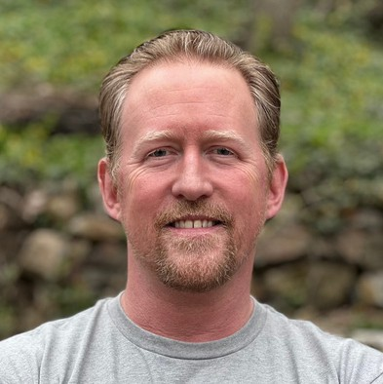
Robert J. O’Neill is one of the most highly decorated combat veterans of our time. He served at SEAL Team Two, SEAL Team Four and eight years at the legendary SEAL Team Six. Having taken part in and leading over 400 combat missions, Rob operated in Liberia, The Balkans, The Persian Gulf and Indian Ocean, Ukraine, Iraq, Afghanistan and Pakistan.
Having been decorated 53 times, his awards include two Silver Stars for gallantry in action against the enemy, four Bronze Stars with Valor to denote heroism against the enemy, a Joint Service Commendation Medal with Valor, a
Navy and Marine Corps Commendation Medal with Valor, three Presidential Unit Commendations
and three Combat Action ribbons to name a few.
Some of Rob’s qualifications include Military Free-Fall Jumpmaster, Tandem Tethered Bundle Master, Naval Special Warfare Scout / Sniper, Breacher, Master Naval Parachutist, Master Training Specialist, Diving Supervisor, Range Officer in Charge for Small Arms, Close Quarters Battle, Breaching, Laser System Safety Officer among many others.
Rob took part in the rescue for Operation Red Wings, which extracted the Lone Survivor, Marcus Luttrell, he was the lead jumper for the rescue operation that saved Captain Richard Phillips from Somali pirates and he was a Team Leader for Operation Neptune’s Spear, the mission to kill Osama bin Laden.
Rob is co-founder of Special Operators Transition Foundation, specializing in assisting Special Operations Forces veterans with the successful transition from the service into their next great career in corporate America.
Rob is the author of the NY Times and London Times Best Selling Memoir THE OPERATOR: Firing the Shots that Killed Osama bin Laden and My Years as a SEAL Team Warrior, and The Way Forward: Master Life's Toughest Battles and Create Your Lasting Legacy.
Rob has been interviewed on Fox News, CNN, CBS, Newsmax and others.

Executive Speakers Bureau • richard@executivespeakers.com

