SAM SILVERSTEIN

FOUNDER OF THE ACCOUNTABILITY INSTITUTE™

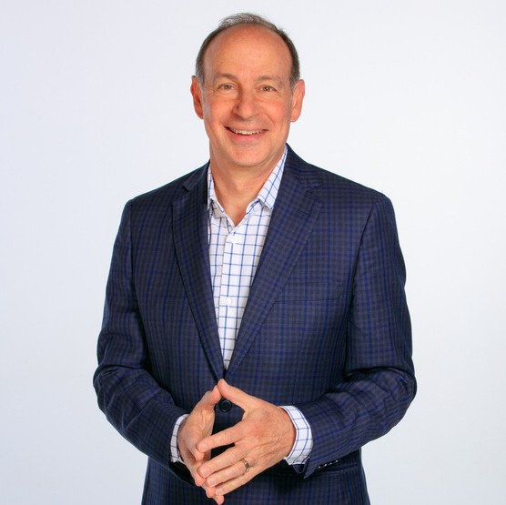
Accountability & Leadership Keynote Speaker Sam Silverstein’s mission is to empower people to live accountable lives, transform the way they do business, and thrive at extraordinary levels. By challenging leaders to shift priorities, cultivate an organizational culture, and inspire both individuals and teams to take ownership in fresh and results-producing ways – he is helping companies dramatically increase productivity, profitability, and growth. Sam has been inducted into the CPAE Speakers Hall of Fame, is a Past-President of the National Speakers Association and Global Gurus has
named Sam Silverstein as one of the World's Top Organizational Culture Professionals.
Sam is the founder of The Accountability Institute™ an organization that certifies advisors to work with leaders and organizations to build greater accountability and develop stronger leaders. He is the author of 12 books including The Accountability Advantage, I Am Accountable, Non- Negotiable, No More Excuses, Making Accountable Decisions, No Matter What, and The Success Model.
As a former executive and owner, Sam successfully sold one of his businesses to a Fortune 500 company. Today, Sam writes, speaks, and consults with organizations around the globe to think differently, work with renewed purpose, and achieve record-breaking results. He works with entrepreneurs, multinational companies, corporations, and government agencies to drive increased accountability, engagement, and productivity.

Executive Speakers Bureau • matt@executivespeakers.com

