JEREMY C. PARK

EMCEE, MODERATOR & CEO OF CITYCURRENT, AN ORGANIZATION COMMITTED TO POWER THE GOOD IN THE COMMUNITY
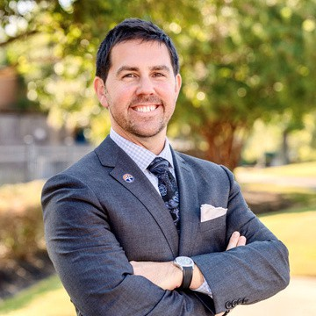
Jeremy C. Park helps individuals and organizations power the GOOD. He is the CEO of cityCURRENT, an author of two books, contributor to Forbes, producer and host of four television and two radio shows and the ChangeMakers podcast, and a sought after speaker inspiring audiences around the nation with his model and the power of Giving for Growth, which helps you achieve higher levels of success by becoming a SPARK for your community.
Park is CEO and the catalyst behind cityCURRENT, an organization connecting businesses with communities.
cityCURRENT is a partnership of more than one hundred businesses, including some of the world’s largest employers, like FedEx, AutoZone, Kroger, and Smith+Nephew that have joined forces and funds to make a difference. The organization connects businesses with community and has teams working in Memphis and Nashville, Tennessee. cityCURRENT hosts more than 300 events each year for enrichment and community collaboration, produces an array of positive-oriented media, and financially and physically gives back to support nonprofits.
Under Park’s leadership, the organization quickly transformed from a small internal-focused networking group, originally called the Lipscomb Pitts Breakfast Club, into a powerful, charitable, external-focused partnership now recognized internationally for its innovative approach to social entrepreneurialism, corporate social responsibility (CSR) and collective impact.
In 2020, cityCURRENT launched an e-learning and online personal development platform, called GROWTHcurrent, where individuals around the world can subscribe and access virtual events with thought leaders and industry experts, along with learning modules and other exclusive content.
Park has received numerous awards and recognitions, like Top 40 Under 40, and has been featured in bestselling books, like The Good Ones: Ten Crucial Qualities of High-Character

JEREMY PARK

BIO CONT’D

Employees by Dr. Bruce Weinstein, along with national and international publications, like Forbes, Entrepreneur, Fortune, Yahoo! News, The Huffington Post, CEOWORLD magazine, and Leader’s Edge.
Park’s first book, Giving Back with Purpose, was released in 2013 by Main Street Books; and his second, Giving for Growth, was first released in 2015 with updated editions in 2017 and 2020. Both books focus on achieving success in career and life while helping others and benefiting your community. Proceeds benefit youth literacy programs.
Park produces and hosts two weekly radio shows that air across nine Cumulus Media stations in Memphis and Nashville; the ChangeMakers podcast; a monthly television show called The SPARK; an annual televised awards show, called The SPARK Awards; and the weekly cityCURRENT TV Show. He also guest hosts the television show A Conversation With, which airs across the PBS network in Tennessee and profiles figures like NASA astronauts and Shark Tank investors.
Additionally, Park is a member and shareholder in Higginbotham, one of the largest independent insurance agencies in the nation. He is an investor in Memphis-based startups, like SweetBio and UpSquad, and serves on the board with Delta Dental of Tennessee, where he also chairs their philanthropic, Smile180 Foundation.
Park graduated in 1999 from the University of North Texas and was distinguished as the University's Top Marketing Student. He was raised in Weatherford, TX, spent eight years in Los Angeles, CA, and now lives with his wife, Meredith, and two boys, in Germantown, TN. He’s been the head tennis professional at Beverly Hills Country Club, worked in national television and radio, and been mentored by entertainment icons, like Merv Griffin. Park serves on many nonprofit and school boards, including Slingshot Memphis, Inc., the University of Memphis LEAD program, and New Leaders, where he currently serves as Memphis Board Chair. He also is a member of The Business Journals Leadership Trust and has enjoyed coaching his younger son's middle school tennis team, finishing the 2022 season as State Champions.

