GEORGE RANDLE

BEST-SELLING AUTHOR OF THE TALENT WAR: HOW SPECIAL OPERATIONS AND GREAT ORGANIZATIONS WIN ON TALENT
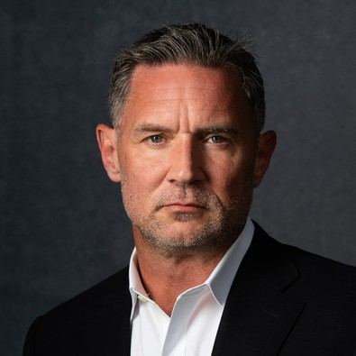
George Randle is an experienced HR executive, veteran, coach, and leader known for selecting, building, and reorganizing teams to reach their full business potential. George has 20+ years of Fortune 100 and Fortune 1000 global Human Resources and Talent Acquisition experience building and coaching elite teams.
George began his professional life by enlisting in the US Army Reserves eventually earning a commission as an active-duty officer. His officer career assignments included Berlin, US CENTCOM, and III Corps with deployments to Africa (Somalia and Kenya), Central
America, and Guantanamo Bay, Cuba. Following his successful military career, realizing that building elite teams are his true passion, George began working in the Human Resources and Talent Acquisition functions serving the last 15+ years as a global HR executive and leader. Over the course of his time as an executive, the teams George has built and led have hired over 85,000 professionals, including over 2000 executives, in over 75 countries. He is also well known for his decades of pro bono work supporting veterans and their transitions.
George is a Hogan (HPI, HDS, and MVPI) Leadership Assessment Certified coach, and co-author of the best-selling book, “The Talent War: How Special Operations and Great Organizations Win on Talent.”

Executive Speakers Bureau • kevin@executivespeakers.com

