HANNAH UBL

COFOUNDER, GOOD COMPANY CONSULTING & FUTURE OF WORK EXPERT

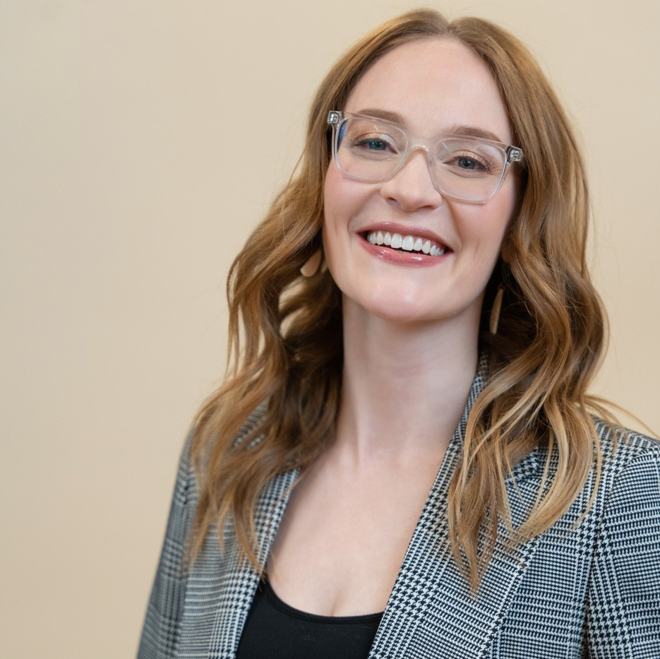
Hannah’s core mission is to help people create workplaces that don’t suck. Since the age of 24, she has been sought after for her fresh insights and dynamic presentations that inspire everyone to make work better.
Insatiably curious, she has dedicated the past decade of her career to researching people at work… and not just top talent and leadership, but also everyone in between. Her skill lies in digesting those findings, and pairing them with the latest workplace and social trends, to deliver custom takeaways for every client. She’s been invited to share those findings with executives, leaders, and
employees in hundreds of organizations like Cisco Systems, PPG, Sodexo, numerous universities, and multiple hospital associations.
As co-founder of Good Company Consulting, she’s committed to flipping the traditional workplace script, throwing out the old “employees are lines on a spreadsheet” in favor of treating people at work more like… well, people.
With heart, deep conviction, and a good dose of self-deprecating humor, Hannah will sweep you along on a journey of insights that lead to deep, lasting mindset shifts about how work works. Don’t be surprised if you feel like grabbing a coffee with her post-presentation and talking about all things people and work (it’s her most common piece of feedback after “that was so helpful!”).

Executive Speakers Bureau • brandy@executivespeakers.com

