FIRST LIVING MARINE TO RECEIVE THE MEDAL OF HONOR SINCE 1973

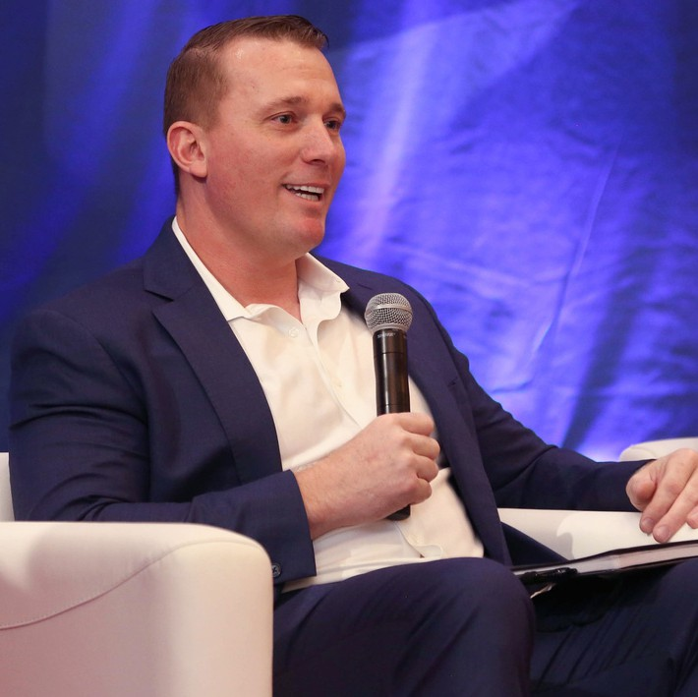
Sergeant Dakota L. Meyer is a United States Marine Corps veteran and recipient of the military’s highest honor, the Medal of Honor. He is the New York Times best-selling author of the book, Into the Fire: A Firsthand Account of the Most Extraordinary Battle in the Afghan War. Meyer earned his medal for his actions during the Battle of Ganjigal, which was part of Operation Enduring Freedom in Afghanistan. He is the first living Marine to have received the medal since 1973 and one of the youngest. Humble and propelled by respect for his fallen comrades,
Meyer insists that he is not a hero and that any Marine
would do the same thing. He addresses inspiration, motivation, courage, leadership/peopleship, believing in yourself, doing what is right, and what happened that day in Afghanistan. Meyer is a successful entrepreneur who also currently serves as a firefighter, EMT, father, and athlete. If he isn't helping in his community, he is either with his family or training for his latest endeavor, an ironman. Meyer is passionate about sharing his lessons he has learned through his journey with others and helping them become the best version of themselves.

The Attack. In September 2009, three US Marines, a US Navy corpsman, and Afghan soldiers went missing in Afghanistan after being ambushed by 50 insurgents. Defying orders, Meyer went into the “killing zone” to help. Through five successive missions over the course of six hours, he helped save the lives of many American and Afghan troops. Meyer also found the bodies of the four missing men, and, with the help of friendly Afghan soldiers, moved the bodies to a safer area where they could be extracted. Meyer suffered shrapnel wounds to his arm and, in a testament to his heroism, did not expect to survive the battle. “I wasn’t really thinking I could die, it was just a matter of when,” he said. “I never thought I was going to come out…[but] that’s what Marines do.” He was 21 at the time.

BIO CONT’D
The Award. During a ceremony on September 15, 2011, President Barack Obama awarded Meyer with the Medal of Honor. Obama called Meyer incredibly down-to-earth, noting that when he tried to tell him that he would be receiving the award, Meyer originally didn’t take the call because was working a new job in construction. Obama jokingly recounted that Meyer said, “If I don’t work, I don’t get paid.” The president called him back during his lunch break and thanked him for taking the call. The two later talked over beers the day before the award ceremony and, according to President Obama, “Dakota is the kind of guy who gets the job done.” Meyer was also inducted into the Hall of Heroes at the Pentagon and honored with a parade.

Civilian Life. With his return to civilian life, Meyer has become an advocate for American veterans. He partnered with the Marine Corps Scholarship Foundation to raise $1 million and issued the “Dakota Meyer Scholarship Challenge to America” to match his efforts. He worked with Toyota and the US Chamber of Commerce to launch the Personal Branding initiative of the Hiring Our Heroes Program to help military veterans and transitioning service members better market themselves to employers. Meyer also wrote a book, Into the Fire: A Firsthand Account of the Most Extraordinary Battle in the Afghan War, which details his journey from a young man raised on a cattle farm in Kentucky to a true American hero. It tells the full story of the chaotic Ganjigal battle for the first time in a compelling and very human way, revealing it as a microcosm of our recent wars. He is also the creator of the podcast Front Toward Enemy with Dakota Meyer and co- author, alongside Robert O'Neill, of The Way Forward: Master Life’s Toughest Battles and Create Your Lasting Legacy – an in-depth, fearless, and ultimately redemptive account of what it takes to survive and thrive on battlefields from Afghanistan and Iraq to our daily lives, and how the perils of war help us hold onto our humanity.
Meyer's days are now dedicated to entrepreneurship, having recently launched his hydration company, Dash Hydrate. Alongside his business pursuits, he serves as a firefighter and EMT, a role that has earned him The Medal of Valor for his exceptional bravery. His commitment to both saving lives in emergencies and promoting hydration reflects a deep dedication to the well-being of others, making him a truly inspiring individual in his community.

